

23CSE211 – Design and Analysis of Algorithms (DAA)
Week 7 – Job Sequencing

By C S Deeraj
CH.SC.U4CSE24106

The Question in particular:
Job Sequencing
To implement the Greedy algorithm for the Job Sequencing with Deadlines problem and determine the optimal sequence of jobs that maximizes total profit.
The profits of the jobs are:
{22, 19, 29, 28, 30, 21, 27, 25, 24, 26, 14, 27, 19, 11}
The deadlines of the jobs are:
{3, 3, 8, 6, 7, 5, 10, 4, 6, 12, 13, 2, 14, 1}
C Code:
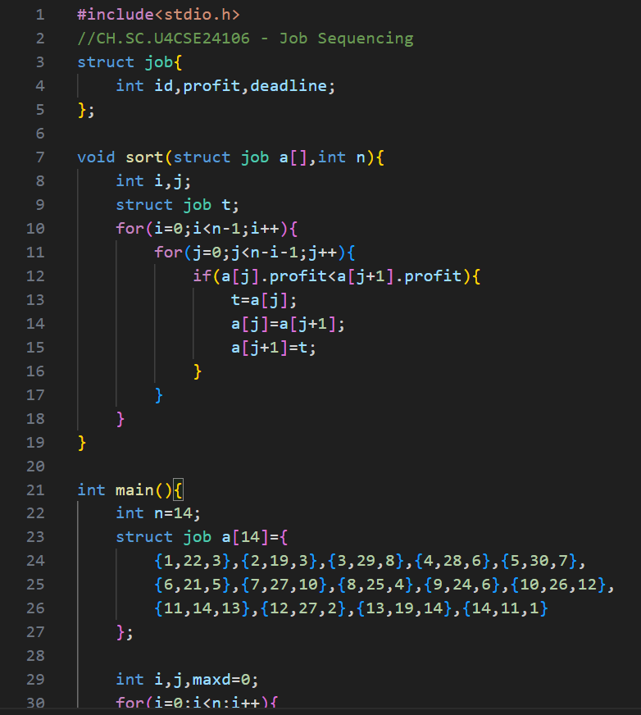
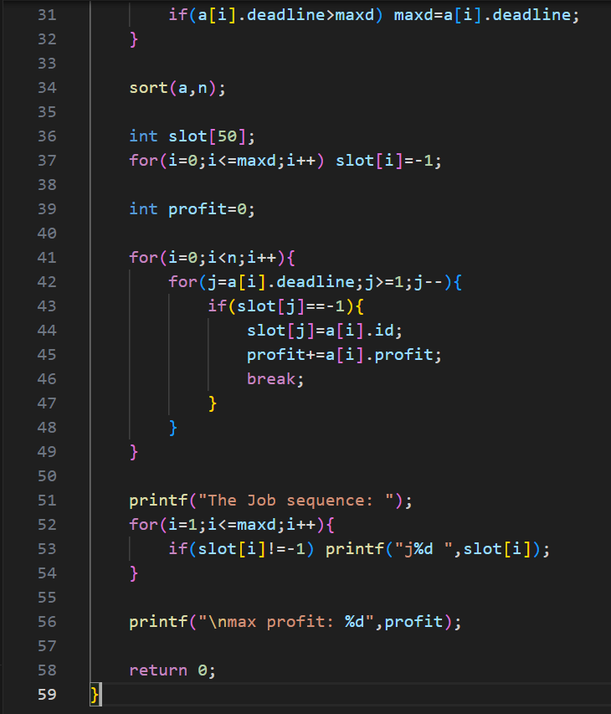

Output: 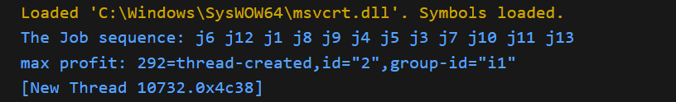

Time Complexity
The time complexity comes from sorting and slot checking. Sorting the jobs using bubble sort takes O(n²). After sorting, each job is placed in a slot before its deadline. In the worst case, we may check many slots for each job. So the overall time complexity becomes O(n²).
Space Complexity
The space complexity depends on the extra memory used. We use a slot array to keep track of filled time slots. The size of this array depends on the maximum deadline. In the worst case, it can be proportional to the number of jobs. So the space complexity is O(n).

